Project: Scalable Web Application with Load Balancing

Services Used
Amazon VPC, EC2, Bastion Host, Application Load Balancer, Auto Scaling Group, Amazon RDS MySQL, Amazon SNS, PM2, Security Groups, Internet Gateway, NAT Gateway, Route Tables, S3

Description
This project deploys a Node.js user authentication web application on AWS using a secure and scalable architecture. The backend application runs on EC2 instances in private subnets, the database runs on Amazon RDS MySQL, and incoming traffic is distributed using an Application Load Balancer. A Bastion host is used for secure SSH access to private instances. Auto Scaling automatically increases or decreases the number of backend servers based on CPU utilization, and SNS is used to send scaling notifications.

Definition
A scalable web application with load balancing is an application architecture in which traffic is distributed across multiple servers and the number of servers is adjusted automatically depending on load. This improves availability, security, and performance.

Scope of the Project
- Deploy a Node.js authentication application on AWS
- Create secure network architecture using VPC and subnets
- Use Bastion host for secure access
- Use private backend server for application hosting
- Use Amazon RDS for MySQL database
- Use Application Load Balancer for traffic distribution
- Use Auto Scaling Group for automatic scaling
- Use SNS topic for notifications
- Optionally host frontend using Amazon S3

This Project Covers
- Secure VPC design
- Public and private subnet setup
- Security group configuration
- Bastion to backend SSH model
- Backend deployment using SCP and SSH
- MySQL database connection using RDS
- Process management using PM2
- Health check configuration
- Load balancing with ALB
- Automatic scaling with ASG
- Scaling notifications with SNS

Methodology

1. Secure Multi-Tier AWS Architecture (Implemented Method)
- Uses VPC, Bastion host, private backend EC2, RDS, ALB, Auto Scaling, SNS
- Backend is not directly public
- Traffic comes through ALB only
- SSH is performed through Bastion only
- RDS is private and accessible only from backend security group
- Auto Scaling uses CPU-based target tracking

2. Single Public EC2 Deployment (Alternative Method)
- Application can be directly deployed on one public EC2
- Easier but less secure
- No load balancing
- No scaling
- Not used in this project because it is not production-style

AWS Services Used in the Project

1. Amazon VPC
Definition: Amazon VPC is a logically isolated virtual network in AWS.
Purpose: To create a secure network environment.
Role: Hosts public and private subnets, route tables, EC2 instances, ALB, and RDS.

2. Amazon EC2
Definition: Amazon EC2 provides virtual machines in the cloud.
Purpose: To run the backend Node.js application.
Role: Bastion EC2 is used for SSH access and backend EC2 runs the application.

3. Bastion Host
Definition: A Bastion host is a public EC2 instance used as a secure jump server.
Purpose: To access private instances securely.
Role: Used to copy files and SSH into the backend EC2 in private subnet.

4. Application Load Balancer
Definition: ALB distributes incoming HTTP traffic across multiple targets.
Purpose: To route traffic to backend instances.
Role: Public entry point for users.

5. Auto Scaling Group
Definition: Auto Scaling Group automatically launches or terminates EC2 instances based on load.
Purpose: To provide scalability and availability.
Role: Creates multiple backend instances when CPU increases.

6. Amazon RDS MySQL
Definition: Amazon RDS is a managed relational database service.
Purpose: To store user registration and login data.
Role: Stores users table and authentication data.

7. Amazon SNS
Definition: Amazon SNS is a notification service for email and message delivery.
Purpose: To notify scaling events.
Role: Sends alerts when instances launch or terminate.

8. Amazon S3
Definition: Amazon S3 is object storage used for static files.
Purpose: To host frontend files.
Role: Optional final step to host frontend separately.

9. PM2
Definition: PM2 is a process manager for Node.js applications.
Purpose: To keep the Node.js server running continuously.
Role: Automatically restarts the application if it stops.
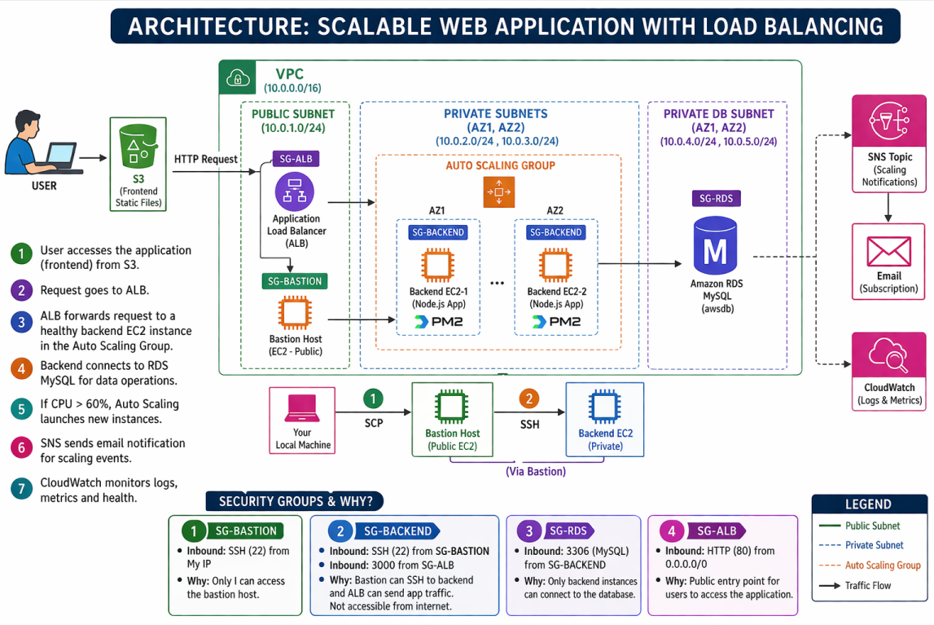

Project Application Details

Application Name
UserAuthenticate-app

Backend Technology
- Node.js
- Express.js
- mysql2/promise
- bcryptjs
- express-session

Database
- MySQL
- Database name: awsdb
- Table: users

Main Features
- User registration
- User login
- Session management
- Logout
- Protected dashboard
- Health check endpoint
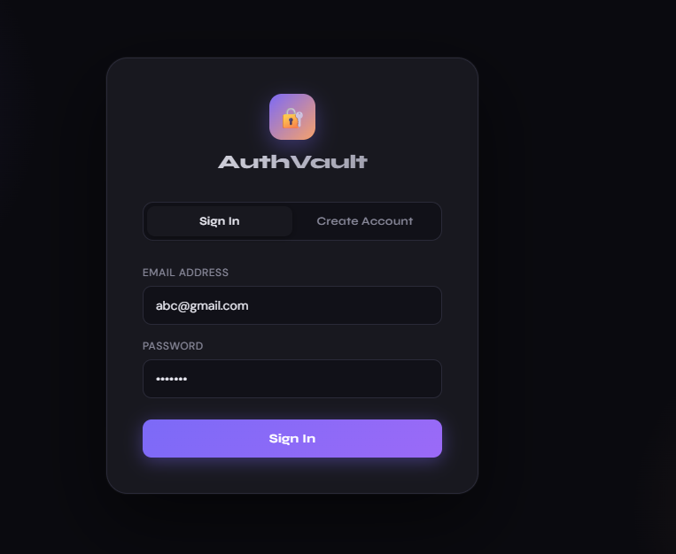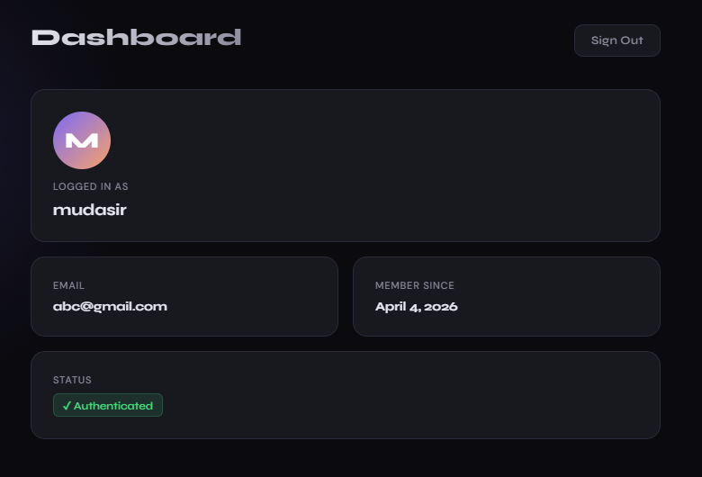

Implementation Steps:

Step 1: Create Custom VPC
Created a custom VPC for isolated network setup.
Purpose: A custom VPC is required to separate public-facing resources from private resources.
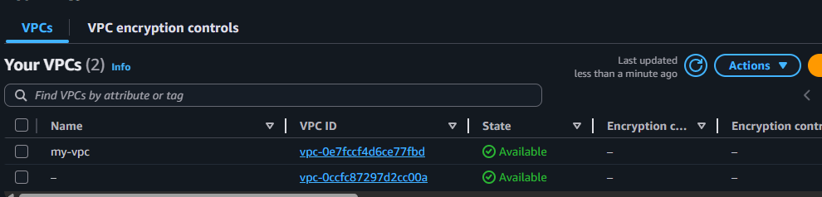

Step 2: Create Subnets
Created:
- Public subnet for Bastion host and ALB
- Private subnet for backend EC2
- Private subnets for Auto Scaling Group and RDS

Purpose:
- Public subnet is needed for internet-facing resources
- Private subnet is needed to secure backend and database servers
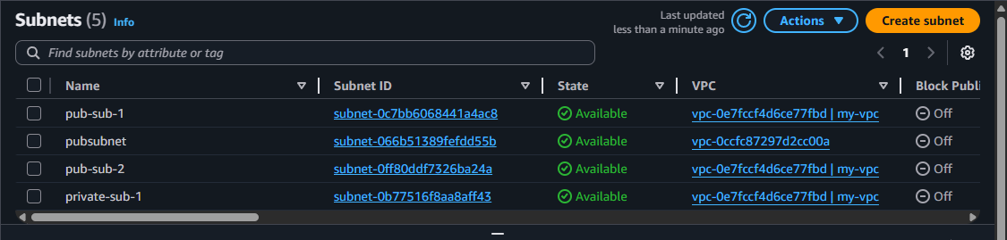

Step 3: Attach Internet Gateway
Attached an Internet Gateway to the VPC.

Purpose: This allows public subnet resources like Bastion and ALB to communicate with the internet.
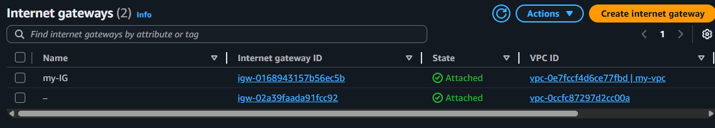

Step 4: NAT gateway:
- Created NAT Gateway in public subnet
- Attached Elastic IP
- Updated private route table to send internet-bound traffic through NAT Gateway
Note: Private backend EC2 used NAT Gateway for outbound internet access to install packages like Node.js, npm dependencies, and MySQL client without assigning a public IP.

Purpose:: This allows private backend EC2 instances to download packages and updates without giving them public IP addresses.
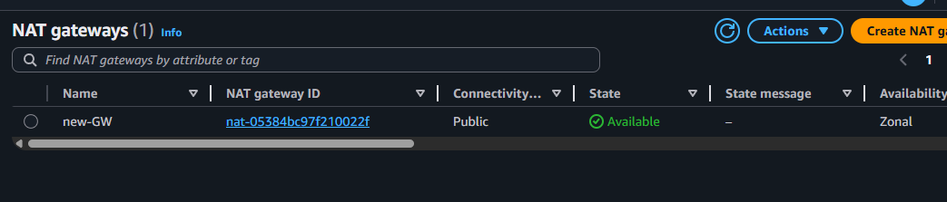

Step 4: Configure Route Tables
Configured public route table:
- 0.0.0.0/0 → Internet Gateway
Configured private route table:
- 0.0.0.0/0 → NAT Gateway

Purpose: Public route table is needed for internet access.
Private route table keeps backend isolated.
Step 4:Route table association
· Public route table associated with:
- public subnet for Bastion
- public subnet(s) for ALB
- subnet containing NAT Gateway
· Private route table associated with:
- backend private subnet
- Auto Scaling private subnet(s)
- RDS private subnet(s), if you used separate DB subnet group
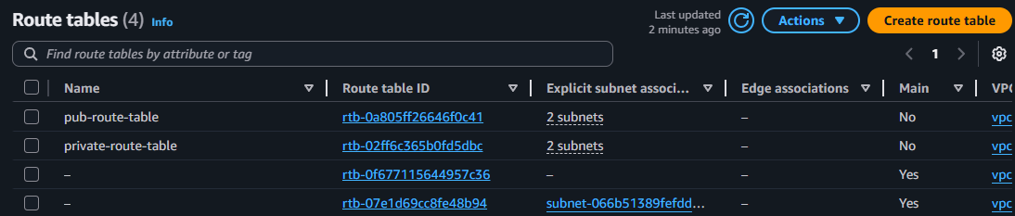

Step 5: Create Security Groups:

1. Bastion Security Group
Inbound rules:
- SSH (22) → My IP

Purpose: Only my laptop should access Bastion.

2. Backend Security Group
Inbound rules:
- SSH (22) → Bastion Security Group
- Custom TCP (3000) → ALB Security Group

Purpose:
- Bastion can SSH into backend
- ALB can send application traffic to backend
- Backend is not directly open to internet

3. RDS Security Group
Inbound rules:
- MySQL/Aurora (3306) → Backend Security Group
Purpose: Only backend application should connect to MySQL.

4. ALB Security Group
Inbound rules:
- HTTP (80) → 0.0.0.0/0

Purpose: ALB is public and accepts user traffic.
Security group setup is a major part of the project and should be described clearly, just like your friend explained permissions and role configuration in detail.
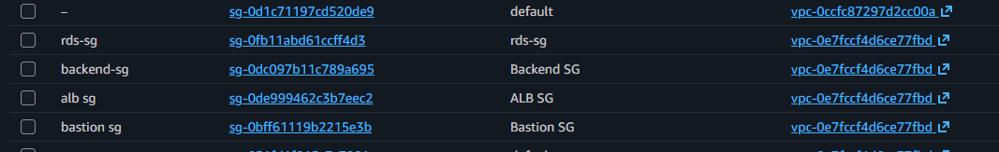

Step 6: Launch Bastion EC2
Created a Bastion EC2 instance in the public subnet.
Configuration:
- Public subnet
- Public IP enabled
- Bastion Security Group attached
- Key pair: awsprojectkey.pem

Purpose: Bastion is the only public server used for SSH access to the backend private server.

Step 7: Launch Backend EC2
Created backend EC2 instance in private subnet.
Configuration:
- Private subnet
- No public IP
- Backend Security Group attached
- Same key pair used

Purpose: Backend should remain private and should not be directly accessible from internet.

Step 8: Connect from Local Machine to Bastion
Used SSH from local machine using (git-bash-terminal):
ssh -i awsprojectkey.pem ec2-user@<BASTION-PUBLIC-IP>

Step 9: Copy Project from Local Machine to Bastion
Used SCP from local machine:
scp -i awsprojectkey.pem -r aws-project ec2-user@<BASTION-PUBLIC-IP>:~
Also copied key file to Bastion:
scp -i awsprojectkey.pem awsprojectkey.pem ec2-user@<BASTION-PUBLIC-IP>:~

Purpose: The project folder must first reach Bastion because backend is private.
The key file is needed on Bastion to connect to backend EC2.

Step 10: Set Key Permission on Bastion
Ran:
chmod 400 awsprojectkey.pem
Purpose: Private key file must have secure permissions to be usable for SSH.

Step 11: Connect from Bastion to Backend
Used SSH from Bastion:
ssh -i awsprojectkey.pem ec2-user@<BACKEND-PRIVATE-IP>

Purpose: Backend is in private subnet and cannot be accessed directly from local system.

Step 12: Copy Project from Bastion to Backend
Used SCP from Bastion:
scp -i awsprojectkey.pem -r aws-project ec2-user@<BACKEND-PRIVATE-IP>:~

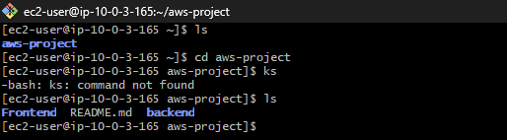

Purpose: The backend application files must be present on backend EC2 for deployment.
- Your current server.js does not contain /health…Add this above your app.post('/api/register'...):
app.get('/health', (req, res) => {
res.status(200).send('OK');
});

Purpose: I created a /health endpoint so that the Application Load Balancer can perform health checks and route traffic only to healthy instances.

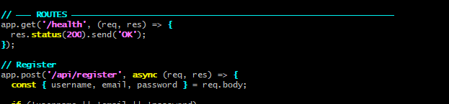

Step 13: Install Node.js on Backend EC2
Ran:
sudo yum update -y
curl -fsSL https://rpm.nodesource.com/setup_18.x | sudo bash -
sudo yum install -y nodejs
node -v
npm -v

Step 14: Run Backend Application:
cd aws-project/backend
npm install
node server.js
This installs dependencies and starts the application.

Step 15: Create Amazon RDS MySQL
Created an RDS DB instance with:
- Engine: MySQL
- VPC: same project VPC
- Private subnet
- Public access: No
- Security group: RDS SG
- Username: admin
- Password: mudasirbhat
- Created/used an RDS DB subnet group with private subnets in multiple Availability Zones.
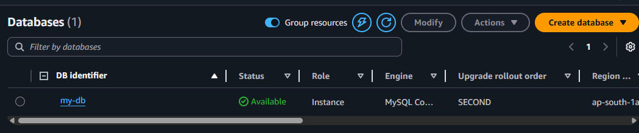

Purpose:: RDS provides managed MySQL for secure and scalable database hosting.

Step 16: Create Database Inside RDS
Connected from backend EC2 using MySQL client.
Installed client:
sudo yum install -y mariadb105
Connected to RDS:
mysql -h <RDS-ENDPOINT> -u admin -p
Created database:
CREATE DATABASE awsdb;
SHOW DATABASES;
EXIT;

Purpose: Creating the RDS instance does not automatically create the application database unless specified.
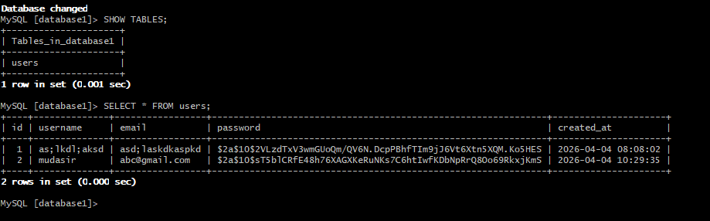

Step 17: Update Backend Code for RDS
Updated server.js database connection:
const pool = mysql.createPool({
host: '<RDS-ENDPOINT>',
user: 'admin',
password: 'YOUR_PASSWORD',
database: 'awsdb',
port: 3306
});

Purpose:: The backend must connect to RDS, not localhost.

Step 18: Health Check Testing:
Tested application on backend EC2:
curl http://localhost:3000/health Expected output: OK
Purpose: To check that the application is running properly and to allow ALB to perform health checks. Step
- Configure npm start: Runs your app using package.json,, · Stops when you close terminal -Not good for server
- Configure PM2 : Runs app in background (like a service),Keeps app running -Auto restart if crash -Works after reboot
Installed PM2:
sudo npm install -g pm2
Started application:
pm2 start server.js --name auth-app Saved process:
pm2 save Enabled auto start after reboot:
pm2 startup
pm2 save
Pm2 status
Give status
Purpose: PM2 keeps the application running in the background and automatically restarts it if the server reboots or the application crashes.

Step 19: Create Target Group
Created target group with:
- Target type: Instances
- Protocol: HTTP
- Port: 3000
- Health check path: /health
Registered backend EC2 instance.
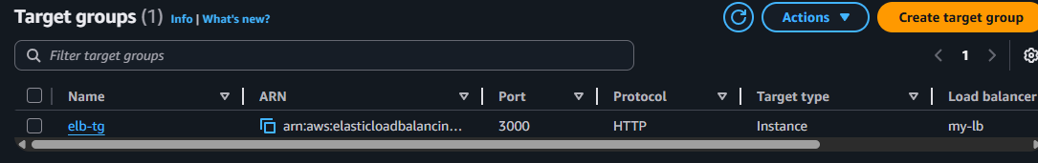
Purpose: The ALB forwards traffic to a target group, and health checks ensure traffic only goes to healthy instances.

Step 20: Create Application Load Balancer
Created ALB with:
- Internet-facing scheme
- Two public subnets
- ALB Security Group
- Listener: HTTP 80
- Forward to created target group
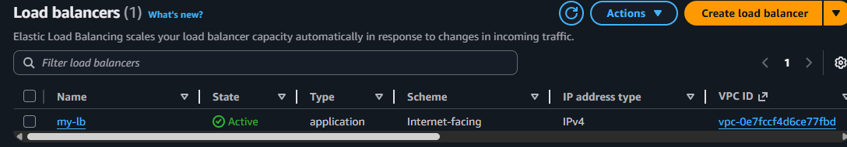

Purpose::ALB becomes the public entry point for the application and distributes traffic to backend instances.

Step 21: Test ALB
Opened in browser: http://<ALB-DNS-NAME>/health

Purpose: To verify that ALB is successfully routing traffic to backend application.

Step 22: Create AMI from Backend EC2
Created an Amazon Machine Image from the configured backend EC2.
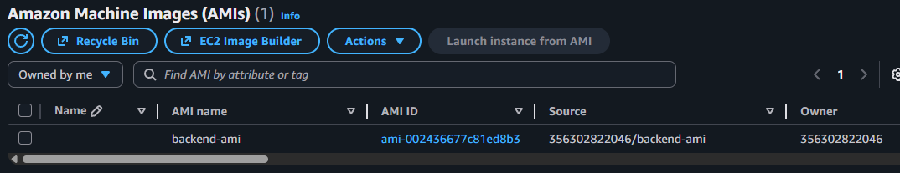

Purpose:: The AMI is used as a template for launching identical backend servers in Auto Scaling.

Step 23: Create Launch Template
Created Launch Template using:
- Backend AMI
- Backend Security Group
- Same key pair
- Private subnet deployment model

Purpose::Launch Template defines how new backend instances are created automatically.

Step 24: Create Auto Scaling Group
Created ASG with:
- Launch Template
- Private subnets
- Attached target group
- Min: 1
- Desired: 2
- Max: 3
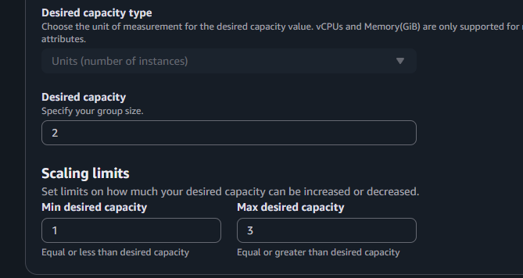

Purpose:: ASG ensures backend capacity can increase or decrease automatically.

Step 25: Configure Scaling Policy
Used target tracking scaling policy:
- Metric: Average CPU utilization
- Target value: 60%
- Instance warmup: 300 seconds

Purpose:: When CPU usage rises above target, ASG launches more instances. When load drops, it removes extra instances.

Step 26: Create SNS Topic
Created SNS topic and email subscription for notifications.

Purpose:: SNS provides email notifications for scaling events.

Step 27: Attach SNS Notifications to Auto Scaling Group
Configured Auto Scaling notifications for:
- Instance launch
- Instance launch error
- Instance terminate
- Instance terminate error
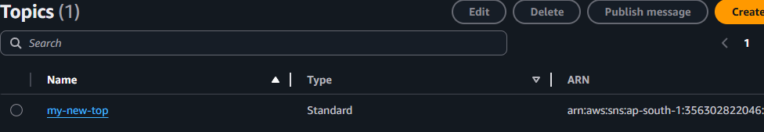

Purpose::This sends alerts whenever scaling actions happen.
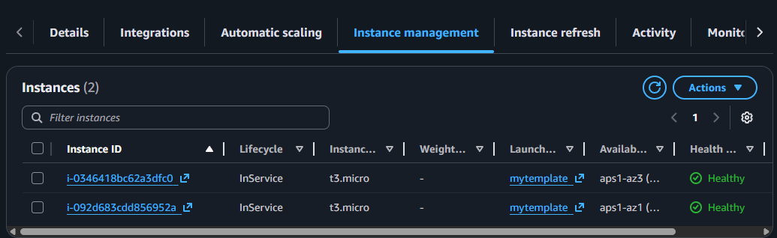
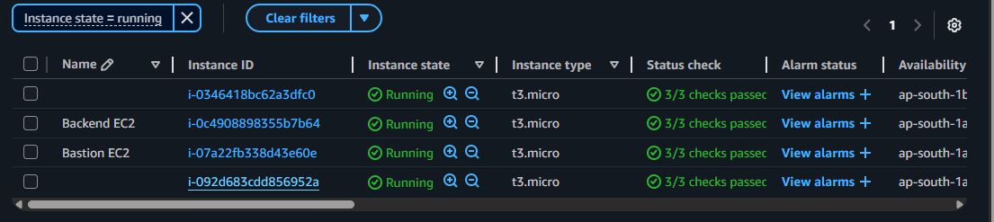
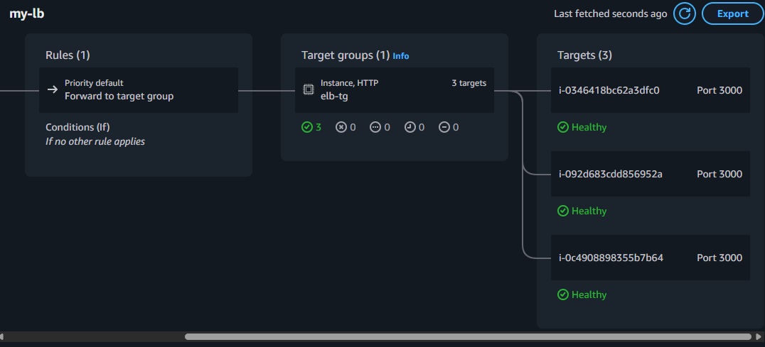

Step 28: S3 Frontend Hosting
steps:
- Create S3 bucket
- Upload frontend static files
- Enable static website hosting
- Update API URL to ALB DNS

Purpose::Frontend can be served from S3 while backend APIs are served from ALB.
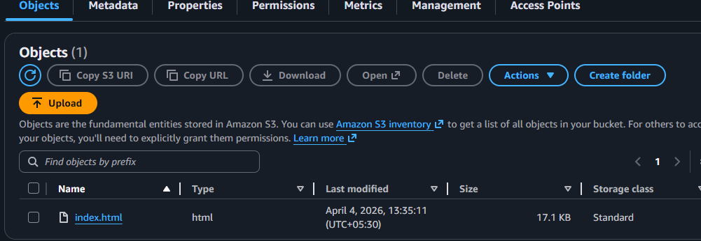

Troubleshooting:

Issue 1: SCP Failed
Solution:
- Ensure key file exists on Bastion
- Run chmod 400 awsprojectkey.pem

Issue 2: ECONNREFUSED 127.0.0.1:3306
Solution:
- RDS was not configured yet
- Replace localhost with RDS endpoint

Issue 3: Unknown database
Solution:
- Connect to RDS and create awsdb

Issue 4: Cannot GET /health
Solution:
- Confirm server.js has /health route
- Restart correct Node process
- Remove older conflicting process

Issue 5: Target Group Unhealthy
Solution:
- Confirm /health path works
- Confirm backend SG allows port 3000 from ALB SG
- Confirm app is running on port 3000

Conclusion
This project successfully deploys a secure and scalable web application on AWS using a multi-tier architecture. The application backend runs on private EC2 instances, the database is hosted on Amazon RDS, and traffic is distributed through an Application Load Balancer. Auto Scaling improves availability and performance by launching additional instances during high load. Bastion host ensures secure administration, and SNS notifications provide visibility into scaling events. This architecture follows real-world cloud deployment practices and demonstrates security, scalability, and high availability.

